Machine Learning - Coursera

Examples:
Database mining
Applications can’t be programmed by hand (handwriting recognition, NLP, computer vision)
Self customizing programs (amazon, Netflix recommendations per person)
Understanding human learning

Supervised learning
Classification problem- Multiple valued output. Trying to predict output that can have multiple values.
Regression problem – Predict continuous valued output. Trying to predict output that has only 1 value.

Unsupervised learning
Cannot be classified

Training set – sample data
hypothesis h(x): Function where x is input, y is output

Linear function hypothesis
y = ax + b
h(x) = θ0 + θ1x

Cost function
Squared error function – Minimize of θ0 and θ1
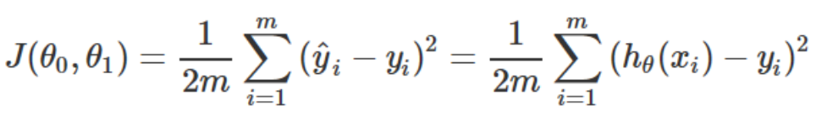
Gradient decent
Way to get the best value of theta
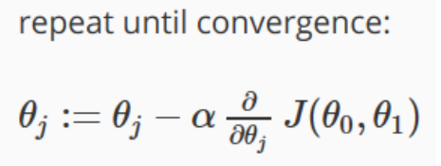
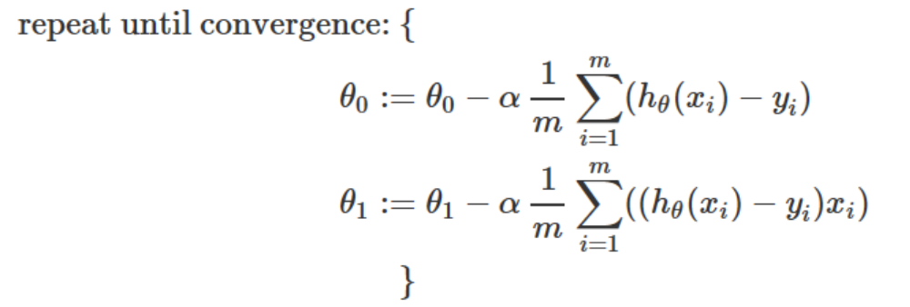
Alpha – Learning rate, rate of decent.
Derivative defines the slope of the cost function

Linear regression with multi-variable (Multi-variate Linear Regression)
Multi-variable hypothesis
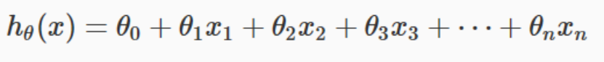
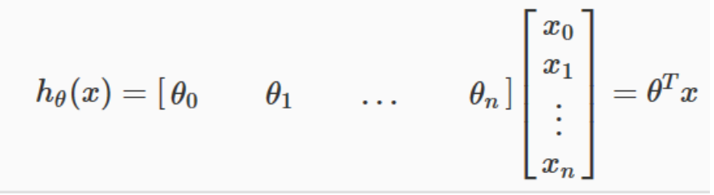

Gradient decent for multi-variable
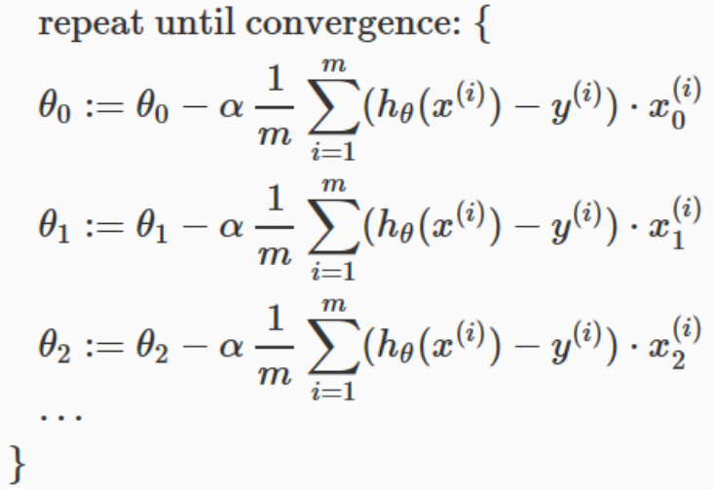
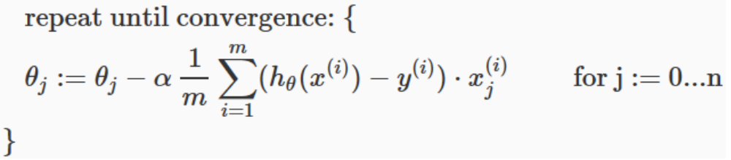

Gradient decent – Feature scaling
If x values are on different ranges, scale x down to make gradient decent easier to converge at global minimum.
X = ( value of x – (average of x) ) / (maximum value – minimum value)
or
X = value of x / (maximum value – minimum value)

Features and polynomial regression
Create new features from an existing feature
For hypothesis function:
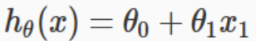
New feature x2 and x3 created from x1 in order to better fix the training set
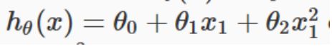
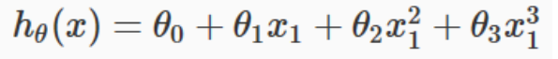

Normal equation
Solve for theta
No need for feature scaling
Due to high cost for matrix computation only use this if size of X is small
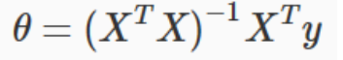

Logical regression (Classification)
Sigmoid function / Logistic function
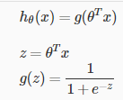
Gives the probability of y = 1

To define the decision boundary where z is the hypothesis equation
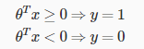

Example:
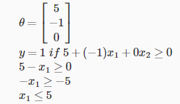

Area to the left of 5, y =1
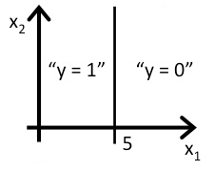
G(z) will be the probability where y = 1.

Cost function for Logistic Regression
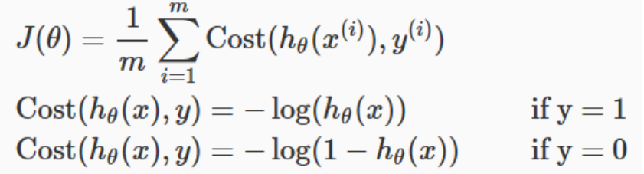
If y = 1, the cost will be 0 if the hypothesis is 0.
if y = 1, the cost will be infinitely large if the hypothesis is 0. Indicating an incorrect hypothesis
(y-axis = cost, x-axis = hypothesis)
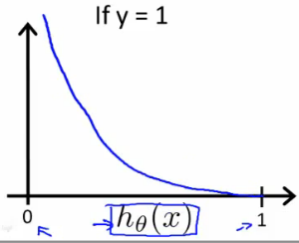
If y = 0, the cost will be 0 if the hypothesis is also 0
if y = 0, the cost will be infinitely large if the hypothesis is 1
(y-axis = cost, x-axis = hypothesis)
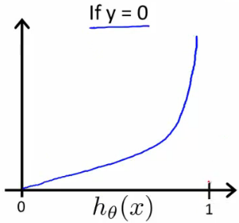
Costs for y= 0, y = 1 can also be written as:
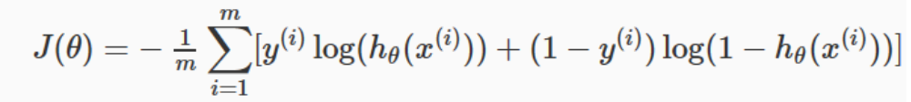
Vectorized implementation:
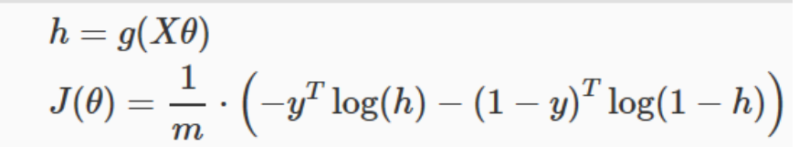

Gradient decent for logical regression
Uses the same algorithm as Linear regression gradient decent
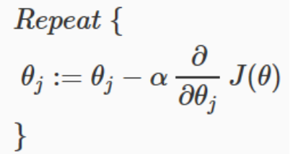
Solving for the derivative gives:
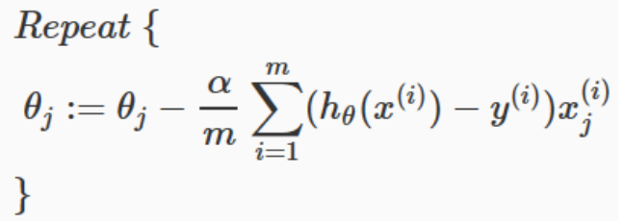
Vectorized implementation gives:
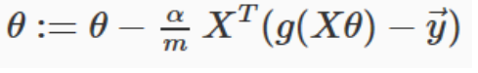
Advanced Optimization algorithms:
  - Gradient descent
  - Conjugate gradient
  - BFGS
  - L-BFGS
Octave code:
Create a function to compute cost:
Returns two vectors.
Jval – Cost function
gradient – Derivative of J theta
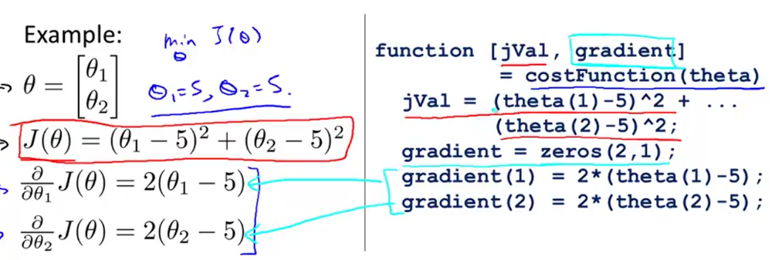

Commands to get the optimized values for theta
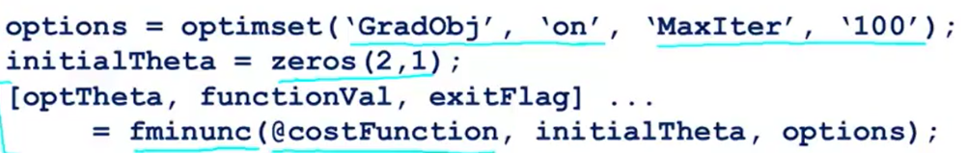
optTheta – Value for optized theta
functionVal - Optimized costCost

Multiclass Classification (one vs all)
Perform binary logistic regression for each case, ant then use the hypothesis that returned the highest value as our prediction.
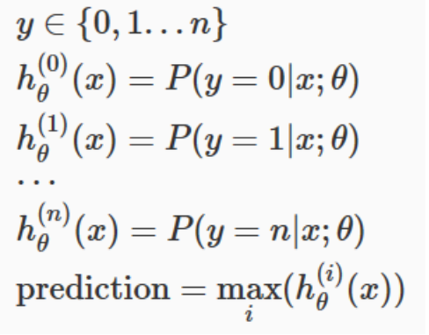
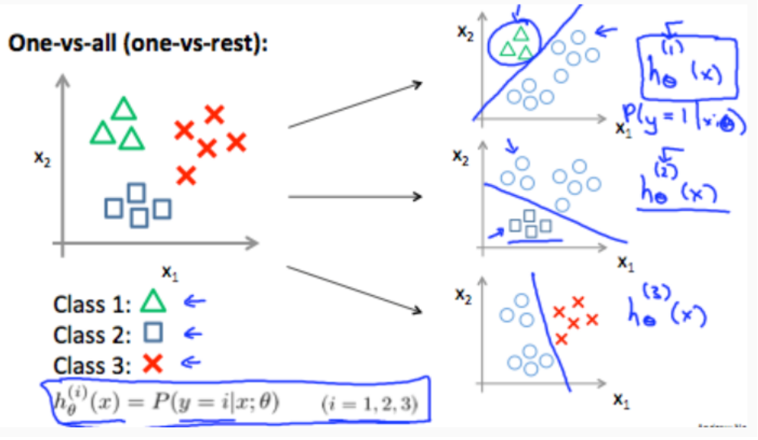

Regularization:
Under-fitting – Hypothesis does not fit the training set
over-fitting – hypothesis fits too perfectly the training set

Reduce theta to solve over-fitting.
Linear regression:
Reduce theta be an amount less than 1 every iteration
Normal equation:
Adds Lamb
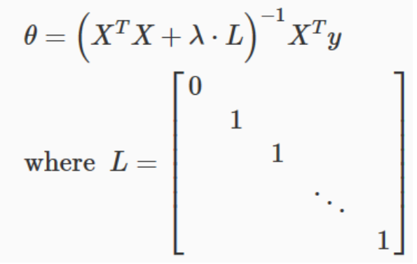
Logistic regression
Cost function with regularization
Gradient descent with regularization
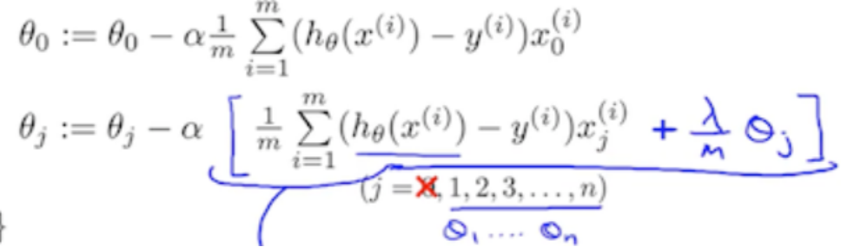

Neural networks
With feature X, predict behavior h(x)

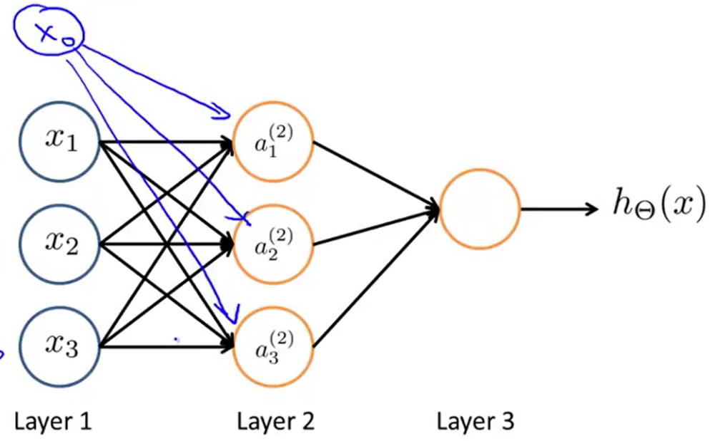

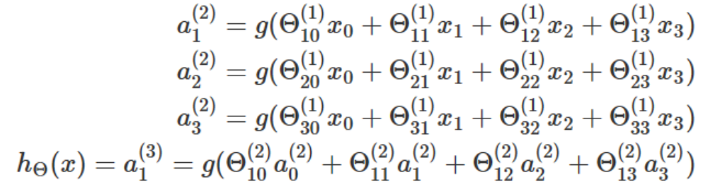
Activation node calculation:

a1 = X
a2 = g(theta1 * a1)
a3 = g(theta2 * a2)

x = n dimensional vector
a1 = n dimensional vector
theta1 = dimension is output x [input + 1]

Logical OR using neural networks:
g(-4.6) = 0.01
g(4.6) = 0.99
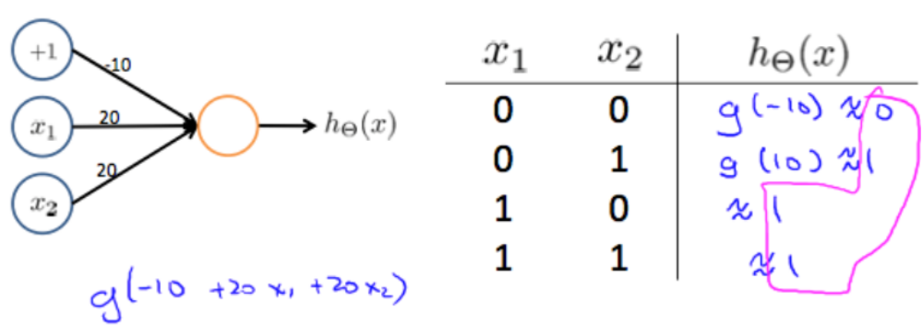

XNOR using 2 level neural network
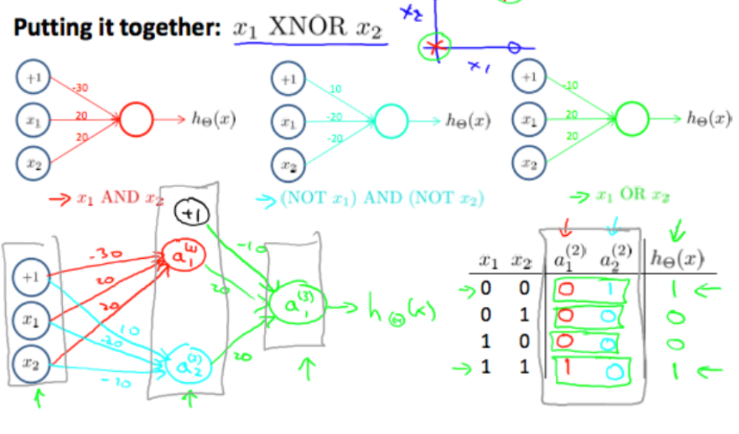
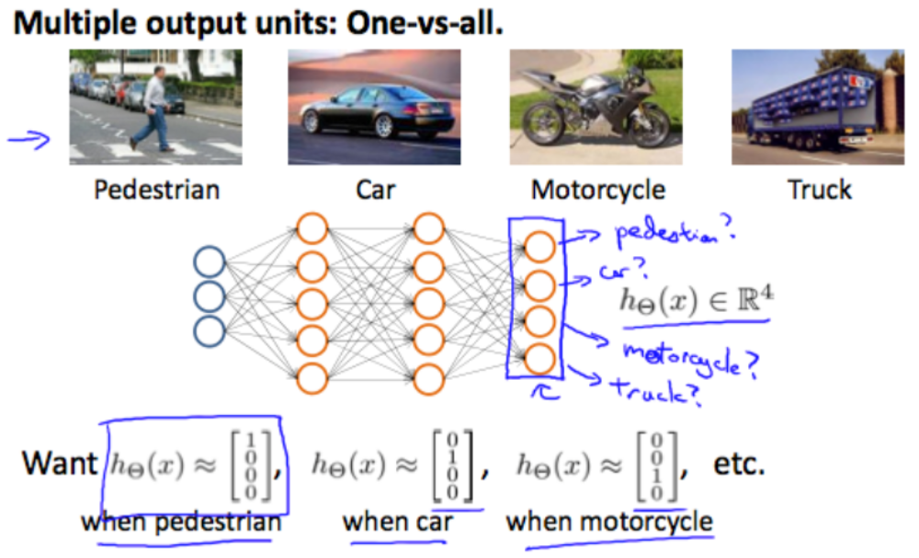
Multiple output:

